~Evolution Review Guide~

- Earth is approximately how old?
- Define fossil.
- Describe the best way to form a fossil.
- How does radiometric dating work?
- Describe how a half-life functions.
- What is the difference between artificial and natural selection?
- List the 4 principles of natural selection.
- Given an example of each of the 4 principles of natural selection.
- When was Charles Darwin born?
- Where did he sail?
- Name the ship he sailed on.
- List 3 species he studied.
- Name the book he wrote.
- Does natural selection work on organisms or on genes?
- What is a homologous structure? Give 2 examples.
- What is an analogous structure? Give 2 examples.
- What is a vestigial structure? Give 2 examples.
- Give an example of adaptation and how it functions in nature.
- Describe how animals use camouflage. Give 2 examples.
- What is mimicry? Give 2 examples.
- What is the Hardy Weinberg equation?
- Define isolation. How does it help or hinder the evolution process?
- Give an example of coevolution.
- List the 2 theories of the rate of evolution.
- What does it mean if an animal is bipedal?

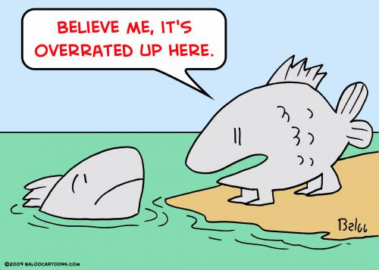
Classification Review Guide
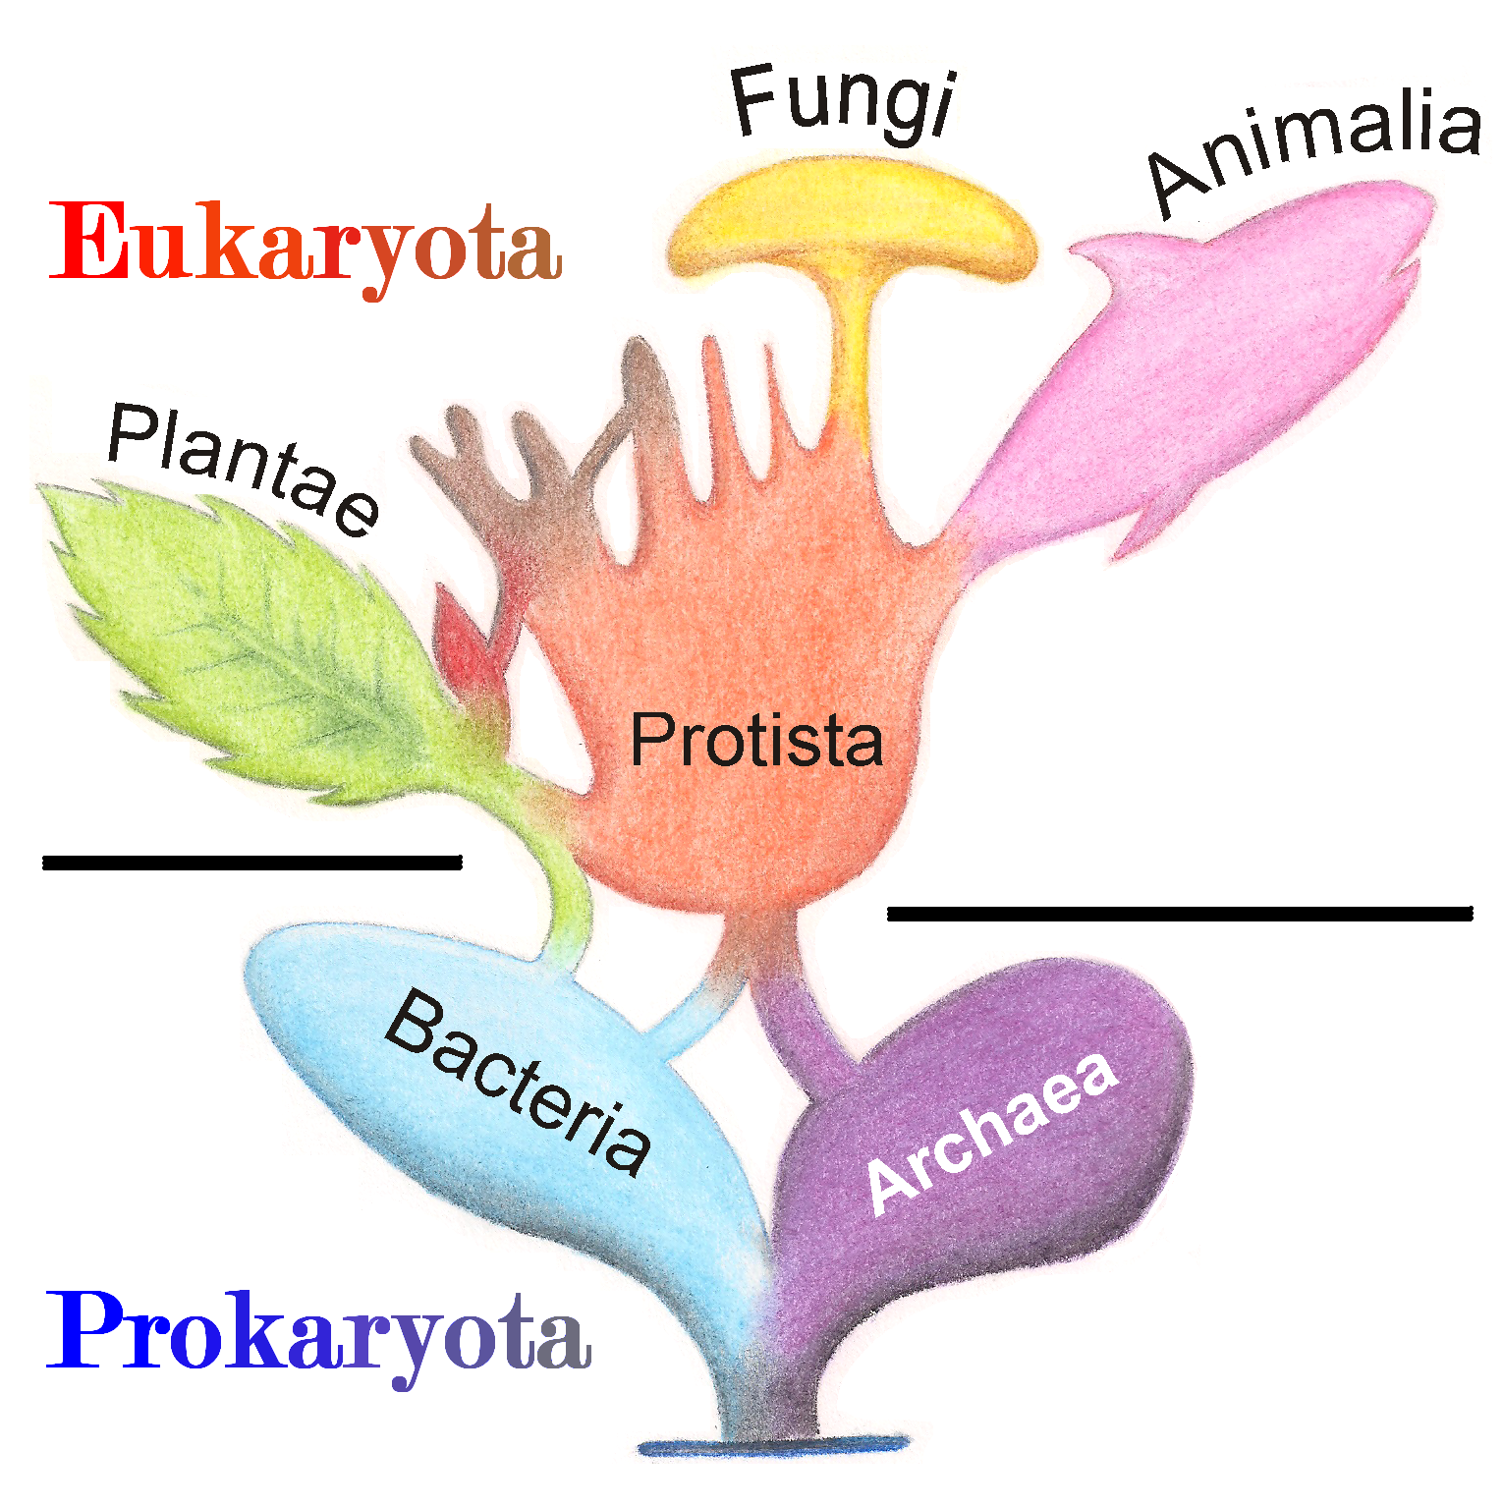
- Why do organisms need to be classified?
- Define taxonomy.
- What are the levels of classification?
- Name the broadest category of classification.
- How would you classify a human using the levels of classification?
- Why do all organisms have a scientific name?
- How do you write the scientific name?
- Define cladistics.
- How is cladistics used in classifying organisms?
- What is a node?
- What is a phylogenetic tree?
- Be sure to be able to read a cladogram or phylogenic tree.
- What is a dichotomous key? How does it work?
- Make sure you can use and make a dichotomous key to determine a group of organisms.
- Describe the 3 main types of Domains.
- Name the main kingdoms of life.
- Complete the table below.
 | Kingdom  Archaea | Kingdom  Bacteria | Kingdom Protista | Kingdom Fungi | Kingdom Plantae | Kingdom Animalia
Number of cells |  |  |  | Mostly multicellular
Cell Type |  |  | Eukaryote |  | Eukaryote
Cell wall |  | Yes |  |  |  | No
Nutrition |  | Autotroph  Heterotroph |  |  |  | Heterotroph  only
Mobile | Yes (cilia, flagella) |  |  |  | immobile
2 Examples |  |  | Amoeba  Euglena | Mushroom  Yeast

