Name: ______________________
CLASSIFICATION NOTES Chapter 18 SOL.1adelm3b4c56ade

How do we identify and name all living organisms?
- We use a classification system which is a way to organize all organisms into specific groups

Common Name vs Scientific Name
What is wrong with using common names to classify organisms? ______________________________________
__________________________________________

Carolus Linnaeus
- First to develop a ______ word naming system called _______________________________________________
- Each ____________________________ is assigned a ____ part scientific name
- The first word is the ________________________ of the organism
  - It must be ___________________________________
- The second word is the __________________________ name of the organism
  - It must be ___________________________
- The entire scientific name is _____________________ or ______________________
- Why does every organism have a scientific name: _____________________________________________
_____________________________________________________________________________________
- Examples: ________________________________________________________________________________

Over time _________________________________________________ wasn’t enough
- Scientists found that we must ___________________________ organisms into _________________ groups
- The goal of ______________________________ (classification) is to organize living things into groups that have ____________________________ meaning
  - These groups are called ____________________
  - This is a hierarchical classification system
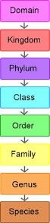
Taxonomic Categories

= this is the _____________________ and most ______________________ of groups

= these are related groups of ____________ that are different but share important ________________________

= these are related _________________________

= these are closely related __________________________

= these consist of several related _________________ (_______________)

= a groups of ________________ that are closely related and share a common ___________________

= the specific organism (group of organisms that are capable of producing _______________ offspring

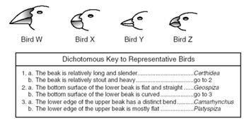

Dichotomous key: ________________________________
_________________________________________________
_________________________________________________

Section 2 Modern Evolutionary Classification Page 490

_____________________________: the evolutionary history of a species

The goal of ___________________________ is to group species into ________________ categories that reflect lines of ______________________________ descent rather than overall ___________________________ and differences

____________________________________: this links groups of _______________________ by showing how evolutionary lines ______________________________ off from common _______________________________
What is a node? _______________________________________________________________________
This demonstrates where derived characteristics began
AKA: _____________________________________________

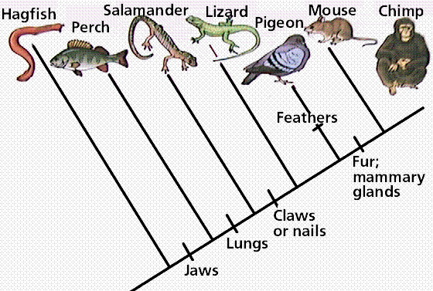

Section 3 Building the Tree of Life

Linnaeus started with only ____________________ groups back in the 1700’s: _______________________ or __________________
But over time different types of organisms were found and the classification system needed to be changed

~The Modern Classification of all living organisms~

DOMAINS | Key Characteristics about each domain
DOMAIN BACTERIA | Kingdom Bacteria
DOMAIN ARCHEA | Kingdom Archaea
DOMAIN EUKARYA | Kingdom Protists, Kingdom Fungi, Kingdom Plantae, Kingdom Animalia

 | Cell Type | Number of Cells | Cell walls | Nutrition | Mobility | 2 Specific Examples
KINGDOM
BACTERIA

KINGDOM
ARCHAEA

KINGDOM
PROTISTIA

KINGDOM
FUNGI

KINGDOM
PLANTAE

KINGDOM
ANIMALIA

Viruses: a ____________________surrounded by a ______________________ and is considered to be ____________________________ and not part of the biological classification system

